Name: _____________________________ Date:__________

Surface Area Study Guide
Find the Surface Area of each Figure:

1.)  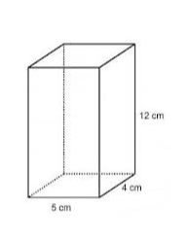 | 2.)  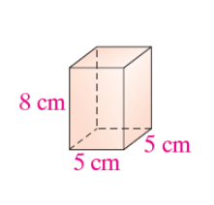 | 3.)  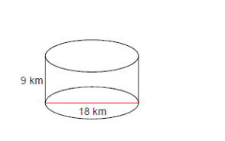
4.)  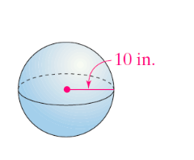 | 5.)  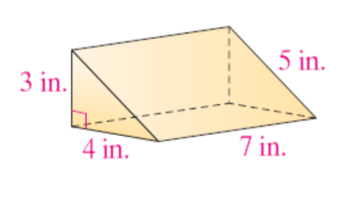 | 6.)  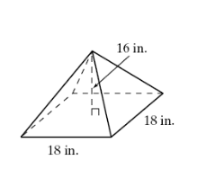
7.)  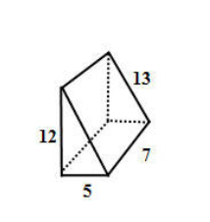 | 8.)  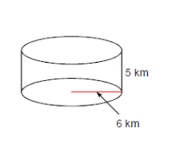 | 9.)  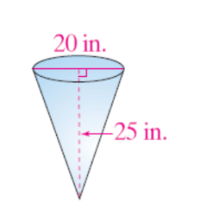
10.) A cone with a 11.) A cube with a 12.) A sphere with a

Radius of 4 cm and a side of 24m diameter of
Height of 8 cm 18 inches

